**Aim:** Implementing the Searching Algorithms

**IDE:** Visual Studio Code

**Linear Search :-**

### Theory: -

### Linear search is a sequential searching algorithm where we start from one end and check every element of the list until the desired element is found. It is the simplest searching algorithm.

### Working of Linear Search :-

### The following steps are followed to search for an element k = 1 in the list below.

### Initial array

### Start from the first element, compare k with each element x.

### Element not found

### Element foundIf x == k, return the index.

1. Else, return not found.

### Algorithm: -

### _______________________________________________________________________________________________________________________________________________________________________________________________________________________________________________________________________________________________________________________________________________________________________________________________________________________________________________________________________________________________________________________________________________________________________________________________________________________________________________________________________________________________________________________________________________________________________________________________________________________________________________________________________________________________________________________________________________________________________________________________________________________________________________________________

### Programming Language: - C++

### Code :-

### #include<iostream>

### #include<vector>

### using namespace std;

### int Linear_Search(vector<int> Array, int key) {

### for (int i = 0; i < Array.size(); i++) {

### if (Array[i] == key) {

### return i;

### }

### }

### return -1;

### }

### void Print_Array(vector<int> Array) {

### for (int i = 0; i < Array.size(); i++) {

### cout << Array[i] << " ";

### }

### cout << endl;

### }

### void Input_Array(vector<int>& Array) {

### for (int i = 0; i < Array.size(); i++) {

### cout << "Enter Element at index " << i << " : ";

### cin >> Array[i];

### }

### }

### int main() {

### int size;

### int key;

### while (true) {

### cout << "Enter The Size of the Array :- " << endl;

### cin >> size;

### if (size >= 1) {

### break;

### }

### cout << "Invalid Size. Size must be a Positive Integer." << endl;

### }

### vector<int> Array(size, 0);

### cout << "Enter The Element for the Array:- " << endl;

### Input_Array(Array);

### cout << "Your Input Array Is :- " << endl;

### Print_Array(Array);

### cout << "Enter the Key to Search In Array :- ";

### cin >> key;

### int ans = Linear_Search(Array, key);

### if (ans != -1) {

### cout << key << " Found at Index - " << ans << " of Array." << endl;

### }

### else {

### cout << "Key is not exists in Array.";

### }

### return 0;

### }

### Output :-

### Space Complexity:- ____________________ Justification: - ____________________________________________________________________________________________________________________________________________________________________________________________________________________________________________________________________________________________________________________________________________________________________________________________________________________________________________________________________________

### Time Complexity:

### Best Case Time Complexity: _________________ Justification: - ____________________________________________________________________________________________________________________________________________________________________________________________________________________________________________________________________________________________________________________________________________________________________________________________________________________________________________________________________________

### Worst Case Time Complexity:- _______________ Justification: - ________________________________________________________________________________________________________________________________________________________________________________________________________________________________________________________________________________________________________________________________________________________________________________________________________________________________________________________________________________________________________________________________________________________________________

**Binary Search**

### Theory: -

### Binary Search is a searching algorithm for finding an element's position in a sorted array.

### In this approach, the element is always searched in the middle of a portion of an array.

### Binary search can be implemented only on a sorted list of items. If the elements are not sorted already, we need to sort them first.

### Working of Bubble Sort

### Binary Search Algorithm can be implemented using Recursion using divide and conquer approach.

### initial array Binary SearchThe array in which searching is to be performed is: let x = 4 be the element to be searched.

### setting pointers Binary SearchSet two pointers low and high at the lowest and the highest positions respectively.

1. 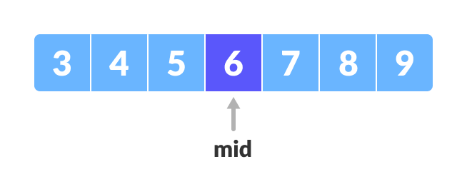Find the middle element mid of the array ie. arr[(low + high)/2] = 6.
2. If x == mid, then return mid. Otherwise, compare the elements to be searched for with m.
3. If x > mid, compare x with the middle element of the elements on the right side of mid. This is done by setting low to low = mid + 1.
4. 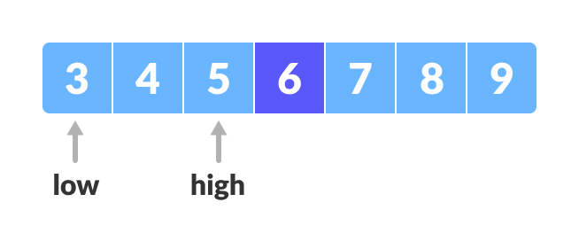Else, compare x with the middle element of the elements on the left side of mid. This is done by setting high to high = mid - 1.
5. 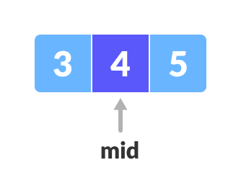Repeat steps 4 to 7 until low meets high.
6. 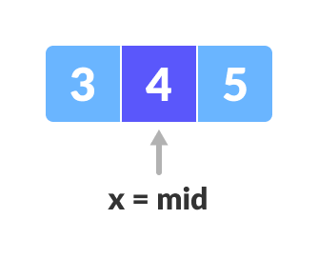x = 4 is found.

### Algorithm: -

### __________________________________________________________________________________________________________________________________________________________________________________________________________________________________________________________________________________________________________________________________________________________________________________________________________________________________________________________________________________________________________________________________________________________________________________________________________________________________________________________________________________________________________________________________________________________________________________________________________________________________________________________________________________________________________________________________________________________________________________________________________________________________________________________________________

### Programming Language: - C++

### Code :-

### #include<iostream>

### #include<vector>

### #include<algorithm>

### using namespace std;

### int Binary_Search(vector<int> Array, int left, int right, int key) {

### if (left <= right) {

### int mid = left + (right - left) / 2;

### if (key == Array[mid]) {

### return mid;

### }

### if (key < Array[mid]) {

### return Binary_Search(Array, left, mid - 1, key);

### }

### else {

### return Binary_Search(Array, mid + 1, right, key);

### }

### }

### }

### void Print_Array(vector<int> Array) {

### for (int i = 0; i < Array.size(); i++) {

### cout << Array[i] << " ";

### }

### cout << endl;

### }

### void Input_Array(vector<int>& Array) {

### for (int i = 0; i < Array.size(); i++) {

### cout << "Enter Element at index " << i << " : ";

### cin >> Array[i];

### }

### }

### int main() {

### int size;

### int key;

### while (true) {

### cout << "Enter The Size of the Array :- " << endl;

### cin >> size;

### if (size >= 1) {

### break;

### }

### cout << "Invalid Size. Size must be a Positive Integer." << endl;

### }

### vector<int> Array(size, 0);

### cout << "Enter The Element for the Array:- " << endl;

### Input_Array(Array);

### sort(Array.begin(), Array.end());

### cout << "Your Input Array Is :- " << endl;

### Print_Array(Array);

### cout << "Enter the Key to Search In Array :- ";

### cin >> key;

### int ans = Binary_Search(Array, 0, size, key);

### if (ans != -1) {

### cout << key << " Found at Index - " << ans << " of Array." << endl;

### }

### else {

### cout << "Key is not exists in Array.";

### }

### return 0;

### }

### Output:-

### 

### Space Complexity:- ____________________ Justification: - ____________________________________________________________________________________________________________________________________________________________________________________________________________________________________________________________________________________________________________________________________________________________________________________________________________________________________________________________________________

### Time Complexity:

### Best Case Time Complexity: _________________ Justification: - ____________________________________________________________________________________________________________________________________________________________________________________________________________________________________________________________________________________________________________________________________________________________________________________________________________________________________________________________________________

### Worst Case Time Complexity:- _______________ Justification: - ________________________________________________________________________________________________________________________________________________________________________________________________________________________________________________________________________________________________________________________________________________________________________________________________________________________________________________________________________________________________________________________________________________________________________

### Conclusion:-

### ________________________________________________________________________________________________________________________________________________________________________________________________________________________________________________________________________________________________________________________________________________________________________________________________________________________________________________________________________________________________________________________________________________________________________